Group Project Members: Jeff Olarte, Raditya Nandadeva Harriman, Harrison Le

**Introduction**

This electronic vendor database is utilized by stores in order to keep track of customer purchases, customer information, and how much products are in stock. The database allows customers to find and purchase electronic products.

**ER Diagram**

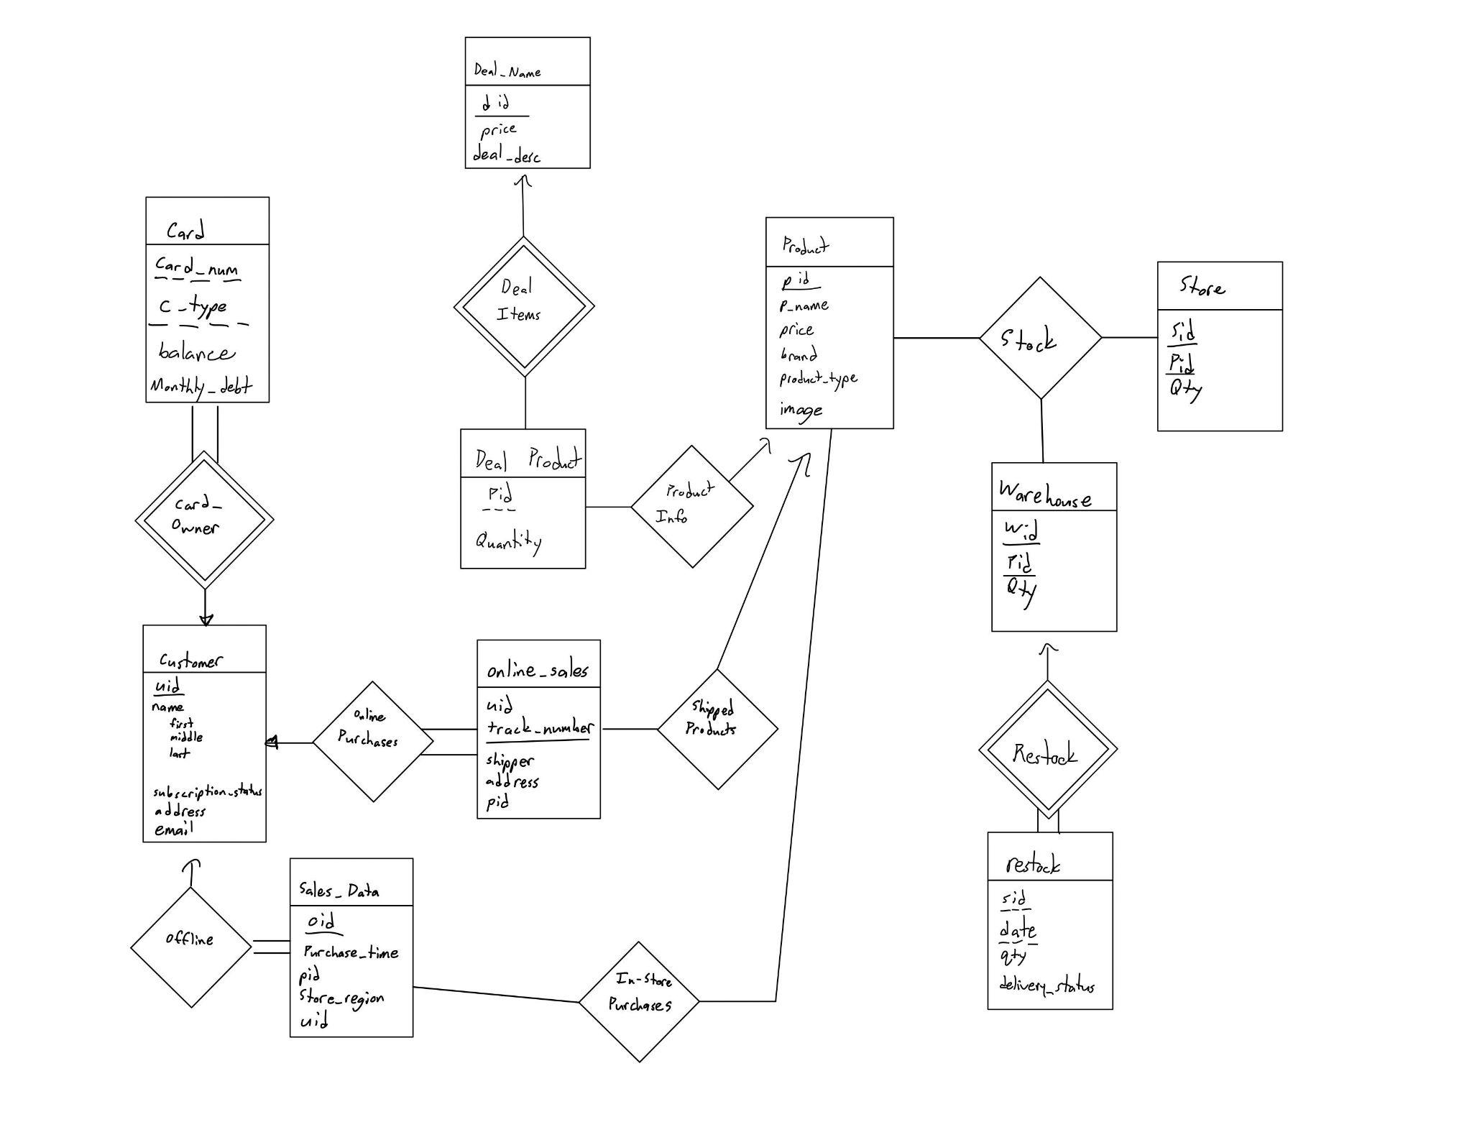

**Functions of Application**

1. Main Page

The main page displays what deals are currently available. It also allows customers to browse the store’s catalog of items for sale. Customers can click either the “Previous” or “Next” buttons to scroll through said products. The name of the product, the name of the brand, and the price is displayed left of the product image.

If you see a product that interests you, you can click on the “Add to Cart” button to save the product to your shopping cart. You can also highlight a deal and click “Add selected to cart” to add the deal to the shopping cart.

If you have an account or need to create one, click the “Sign In” button.

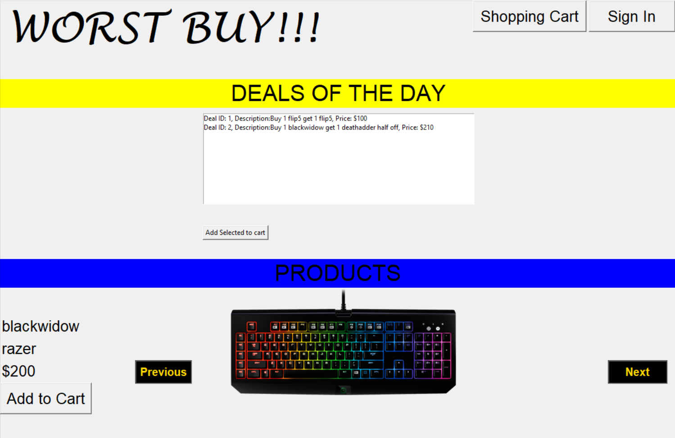

1. Sign-In Page

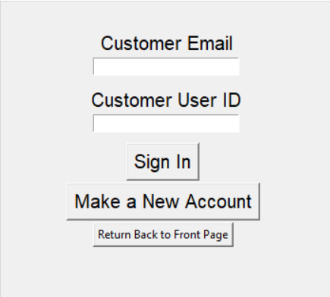

If you have an account, simply type your email and user ID into the appropriate text boxes. Click “Sign In” to reach the Customer Profile Page. If you do not have an account already, you can click “Make a New Account”.

1. Create New Account

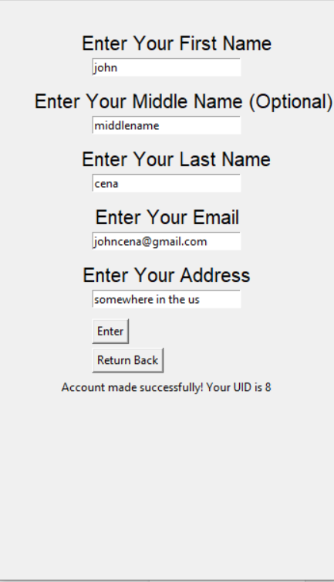

Enter the appropriate information to their respective text boxes. Upon clicking the “Enter” button, the window will give you your UID. Remember this UID as well as your Email to log in. When finished, click “Return Back” to return to the Sign-In Page.

1. Customer Profile Page

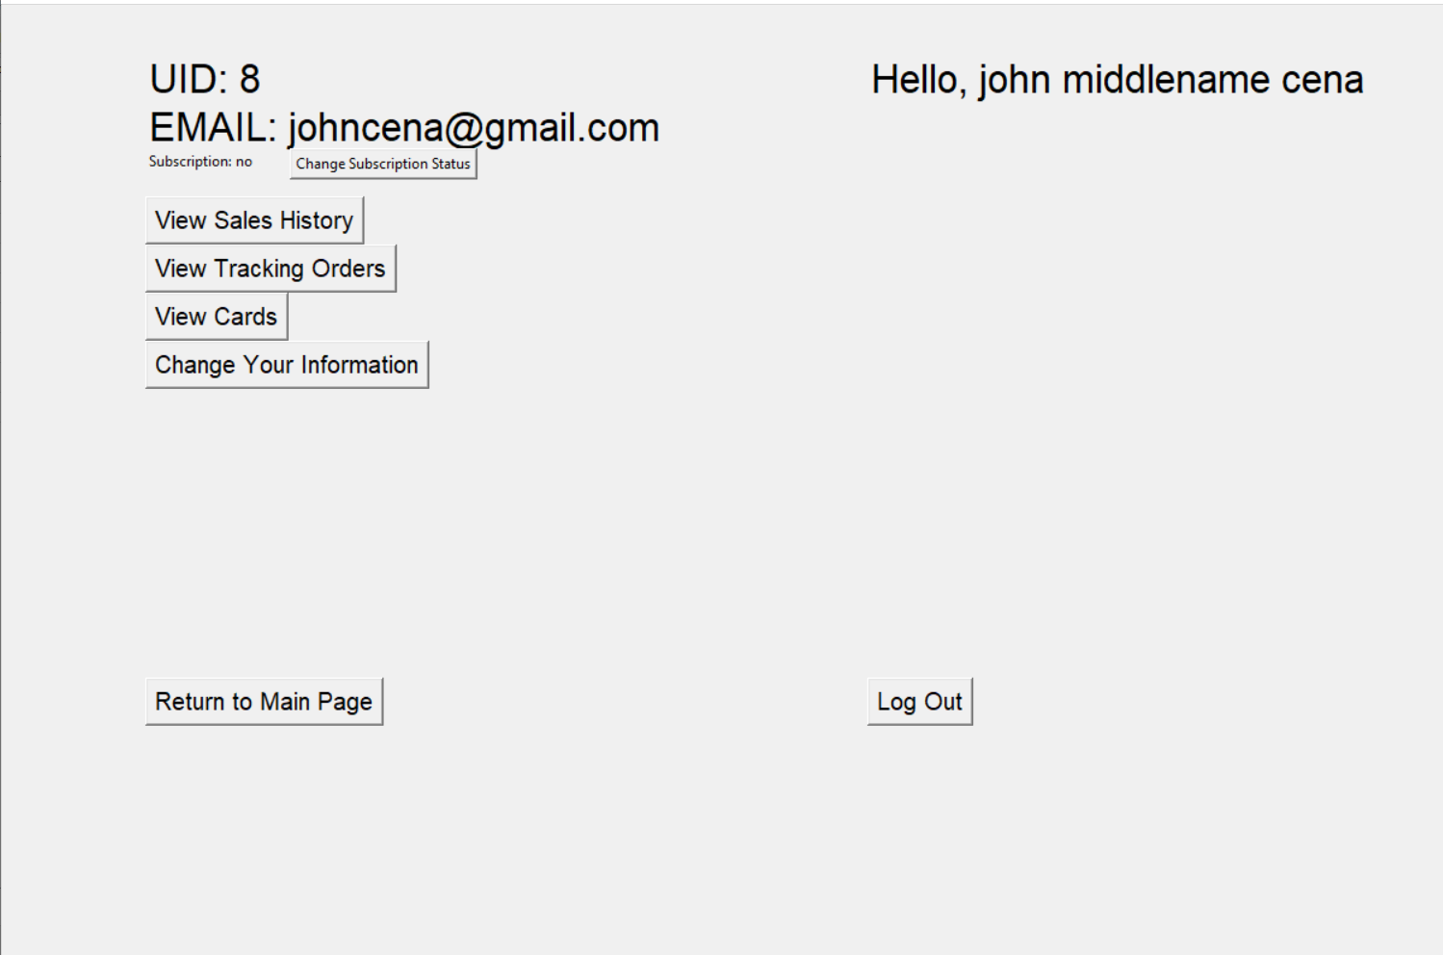

4.1) Change Subscription Status

If you want to change the account’s subscription status for free, click “Change Subscription Status”.

4.2) View Sales History

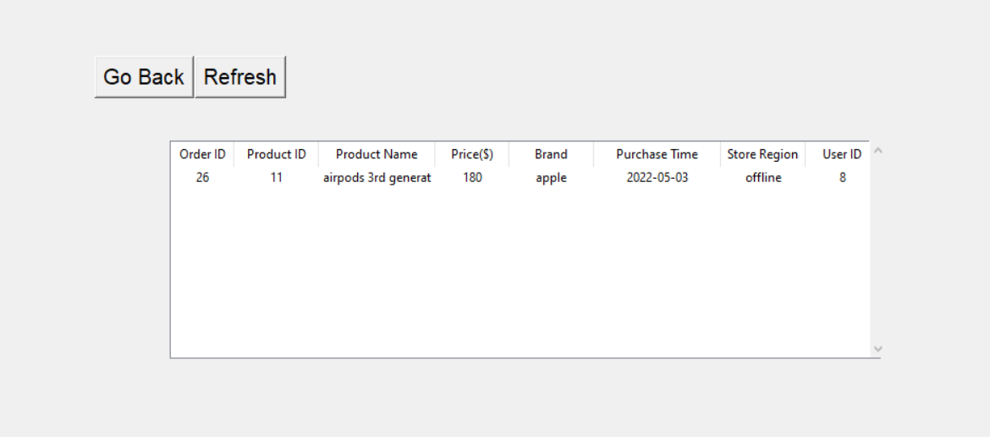

Click on “View Sales History” to view all your past purchases.

4.3) View Tracking Orders

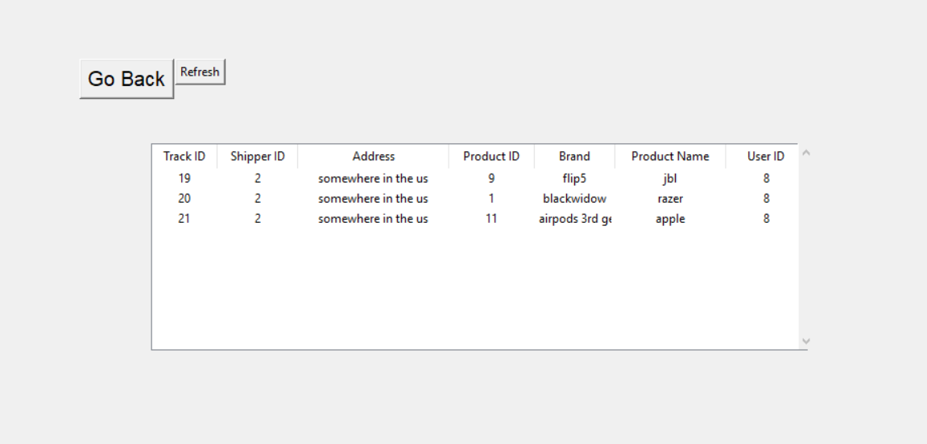

Click on “View Tracking Orders” to view all orders that are currently being shipped to you.

4.3) View Cards

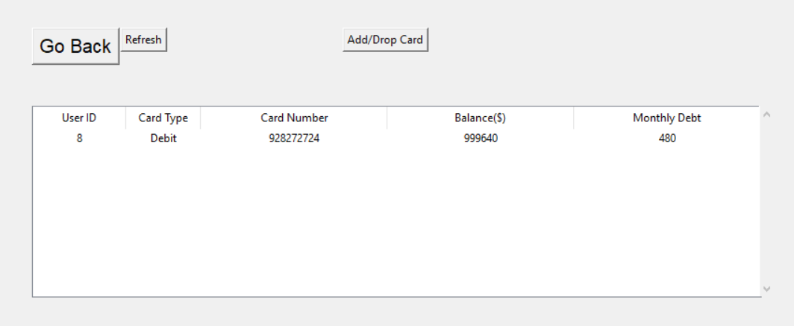

Click on “View Cards” to view all cards associated with your account. Click “Add/Drop Card” to modify this information.

4.3.1) Adding Cards

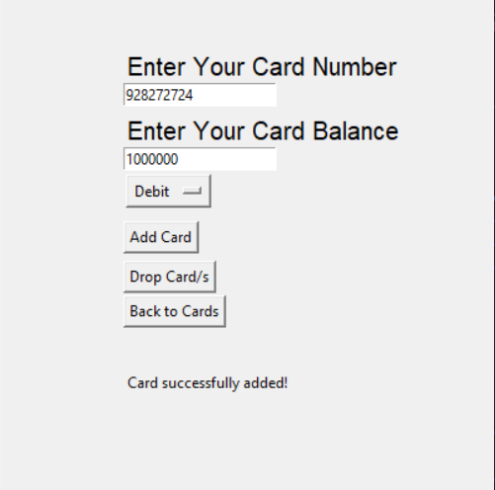

Enter your card’s information and click “Add Card”

4.3.2) Dropping Cards

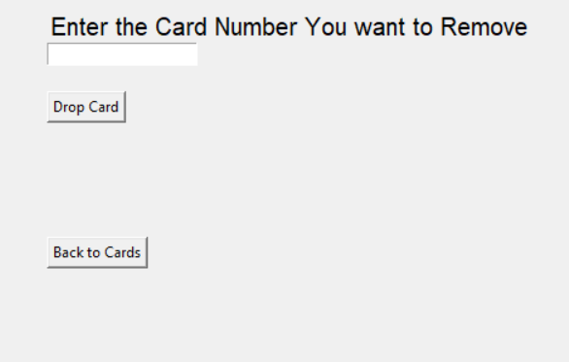

Click “Drop Card/s” and enter the card number of your choice that you want to disassociate with your account.

4.4) Change Your Information

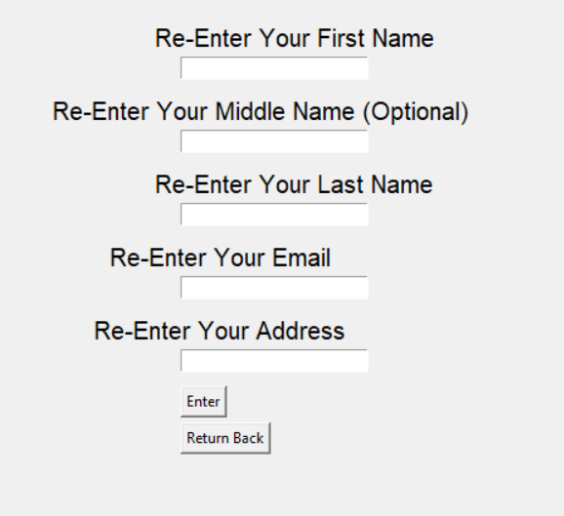

Enter information you want associated with your account and click “Enter”. If you want to change your mind, simply click “Return Back”.

1. Shopping Cart

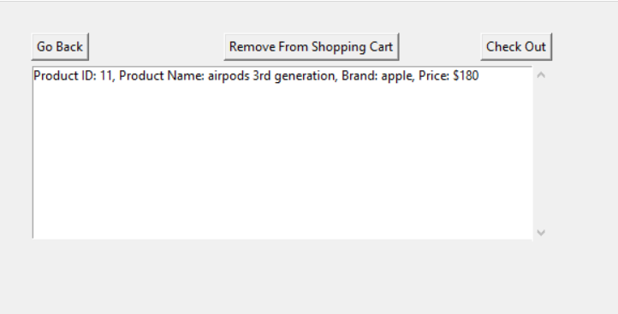

The shopping cart window tells you what products you will purchase prior to check out. If you want to remove an item from your shopping cart, highlight the item by clicking on it and click on the “Remove From Shopping Cart” button. Once you are satisfied with your shopping cart list, click the “Check Out” button to finalize your purchase. Note that you must be signed in to check out products. Failure to do so will result in a prompt that tells the user to sign in first.

5.1) Checkout

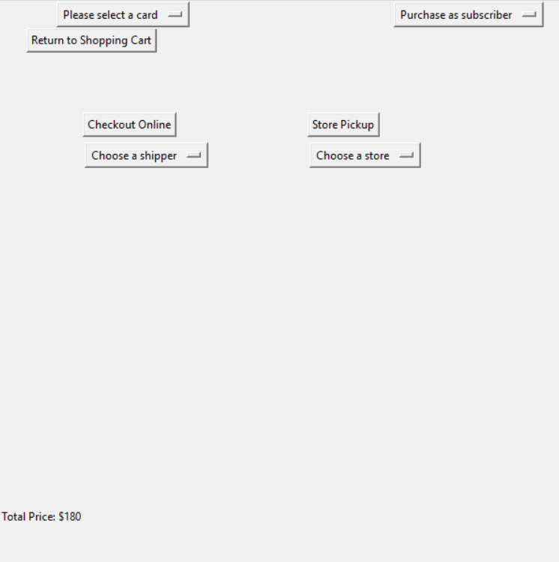

The user must click on the “Please select a card” drop-down menu and select a card of their choice. They must also click on the “Purchase as subscriber” drop-down menu and choose if they want to make this purchase as a subscriber or not. Purchasing as a subscriber lets you be billed once per month and not immediately after purchase. The last action the user must do is to decide if they want to have the products delivered to them or to a store where they will pick up said products. If the user decides to have the products shipped directly to them, they must click on the “Choose a shipper” drop-down menu, select the shipper of choice, and click “Checkout Online”. If the user decides to have the products dropped off to a store for pickup, the user must click the “Choose a store” drop-down menu, click the appropriate store, and then click “Store Pickup”.

**Member Contributions**

The whole group worked together on every stage of the project to ensure that if one made a mistake, the others were more likely to catch said mistake.

Just in case the submission file containing the python script and SQL script could not be opened, the links are:

* Github: <https://github.com/radityaharriman/CS425-Electronic-Vendor-Project>
* Video: <https://drive.google.com/file/d/1R_KDa_zLy7EJYNgcX4SH2XqAt59Xql_K/view?usp=sharing>